Dendrogram for Different Linkage functions

Linkage function : Single

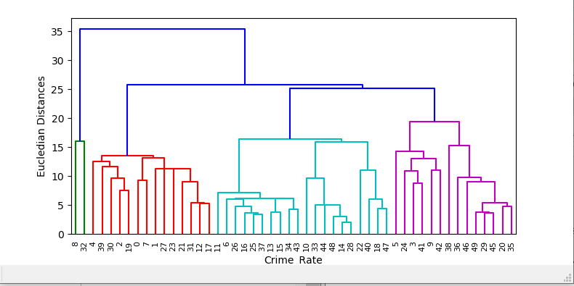

Linkage function : Complete

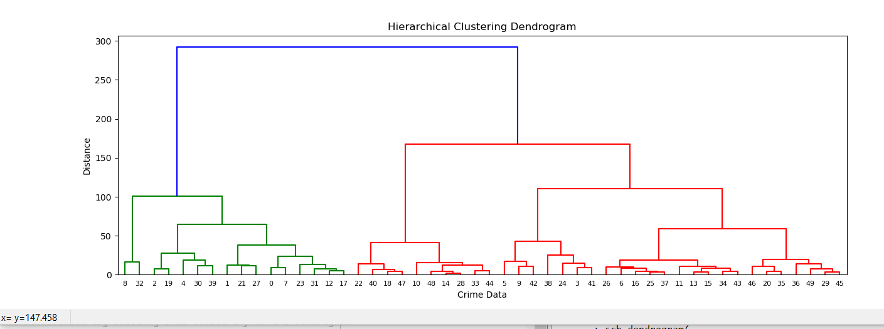

Linkage function : Ward

